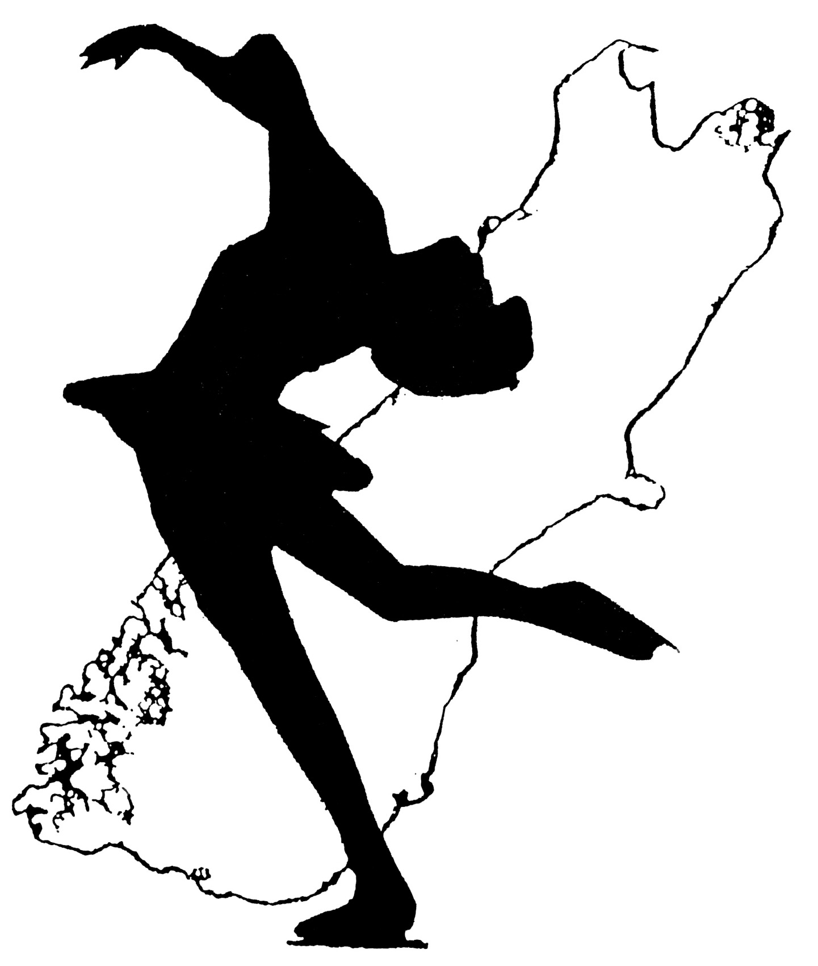
South Island Ice Skating Sub-Association

ANNOUNCEMENT
2014
SOUTH ISLAND FIGURE SKATING CHAMPIONSHIPS
Alpine Ice Sports and Entertainment Centre
495 Brougham Street, Opawa
Christchurch
Ice surface 26 x 56 metres
FRIDAY 22 – SUNDAY 24 AUGUST 2014
Co-hosted by:
Canterbury Masters Figure Skating Club (Inc) &
Centaurus Ice Skating Club (Inc)
Attached forms:
1 SI Champs Requirements and Eligibility
2 Planned Program Content Sheets (PPC's)
3 Individual Entry Forms & List of Entry Fees
4 Club Summary Form
CLOSING DATE FOR ENTRIES: Monday 21st July 2014
COMPETITORS: Entries & Entry Fees must be sent via your club so that they can be received by the
SIISSA secretary no later than 21st July. Your club will set a deadline for this. Entries will not be accepted without a completed PPC, either on the attached form or through the NZIFSA website

CLUB SECRETARIES : All entries must be listed on the Club summary form. Send summary and individual entries to:
SIISSA Secretary
June Laird
P O Box 1022
Christchurch
June Laird
SIISSA Secretary
04/05/2014

